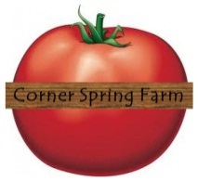
Grilled Kale Toasts – From Food & Wine
½ C. Greek Yogurt 6 Tbsp. EVOO
1 tsp. lemon juice 1 tsp whole grain mustard Salt & Pepper
1 Bunch Tuscan Kale 1 Garlic Clove ½ C. pecorino cheese-shaved
Four 1 inch slices of Ciabatta bread, Cuban, friend or Italian all hold up well.
Directions: Preheat grill, (You can also high roast the kale in your oven at 450). In a large bowl, whisk the yogurt with EVOO, lemon juice and mustard. Season with Salt and Pepper. Working in two batches, grill the kale over moderate heat, turning until lightly charred, about 3 minutes per batch. Discard ribs and chop kale. Add to yogurt dressing and toss to coat. Brush one side of each bread slice with oil and grill oil side down. Rub the grilled sides of breadth with cut garlic close. Top with the kale mixture and a little bit of cheese.
Naturally Grown, Locally Fresh” Cornerspringfarm.net
y!

